**Assignment 4 – Extra credit**

Team Name: TeamName

**NUID/ Name** , *Work distrubution*:

1. **001304148/ Lin, LiangYen**, *register airliners and Extra credit (UML)*

2. **001304955/ Tsai, YuTing**, *Manage Travel Agency*

3. **001372878/ Kuo, DahWei**, *Mange Customer*

Explanation of implementation:

The main goal of this part is to extend the services of the travel agency. So in MainJFrame, we’ll create a new button “services request”, which allow the user to request help from the travel agency. In Service request page, a customer can choose which of the services that he/she needs, and input their destination and date. For Travel Agency, they can manage the request sent by Customer through Manage Customer page. In this page, we can add three more buttons, which are “Hotel Service”, “Rental Service”, and “Travel Plan Service”. While pressing those buttons, travel agency will be redirect to the page of each service. The requests sent by the customer will also displayed in this page, so the travel agency know which service the customer needs.

In “Hotel Service”, by searching the location of a customer’s destination, the system will output all the hotels in the nearby area. To achieve this, we’ll create a new class ”Hotel Class”, which will gather the information of hotels around the world, including address, name, description(include price) from the database. Besides, travel agency will also be available to delete or edit the hotel depends on the customer’s feedback of the hotel.

In “Rental Service”, by searching the location of a customer’s destination, the system will output car renting company near the airport. So we’ll create a “Rental Class”, which allows the travel agency to book a car for their travel.

As for the Travel plan, the travel agency can create their own database which include all the tourist spots around the world. With the destination of a customer, the travel agency can collect the time of the arrival of the flight, and then find some tourist spots that fits the time of the customer. Of course, the travel agency will be able to edit, add, and delete tourist spots, based on customer’s feedback.

So to sum it up, there will be a new button and new page, ”Services request” in MainJFrame, which allow a customer to send request. In Manage customer page, there will be three more buttons and three more pages which are the three extension of this system, which allow agency to receive request from a customer and to book the hotel, rent a car, and plan the vacation for a customer.

Object Diagram:

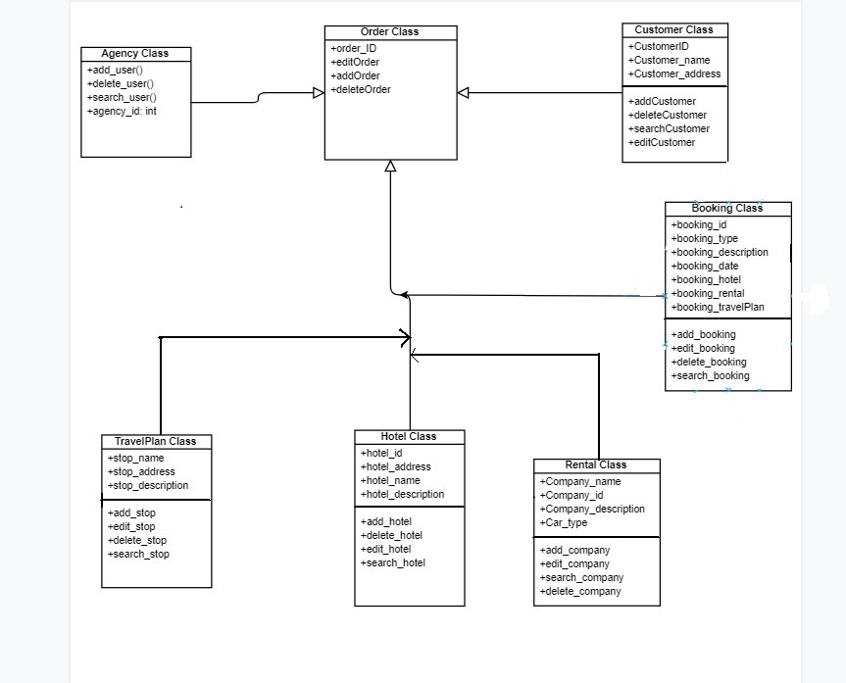

The order class will gather the request from a customer. In booking class, the travel agency can book a hotel, a tourist spot, or a car rental for the customer.

In Hotel Class, we can gather information from the database which can be created by the travel agency itself. As for the Rental Class and TravelPlan Class.

Sequence Diagram:

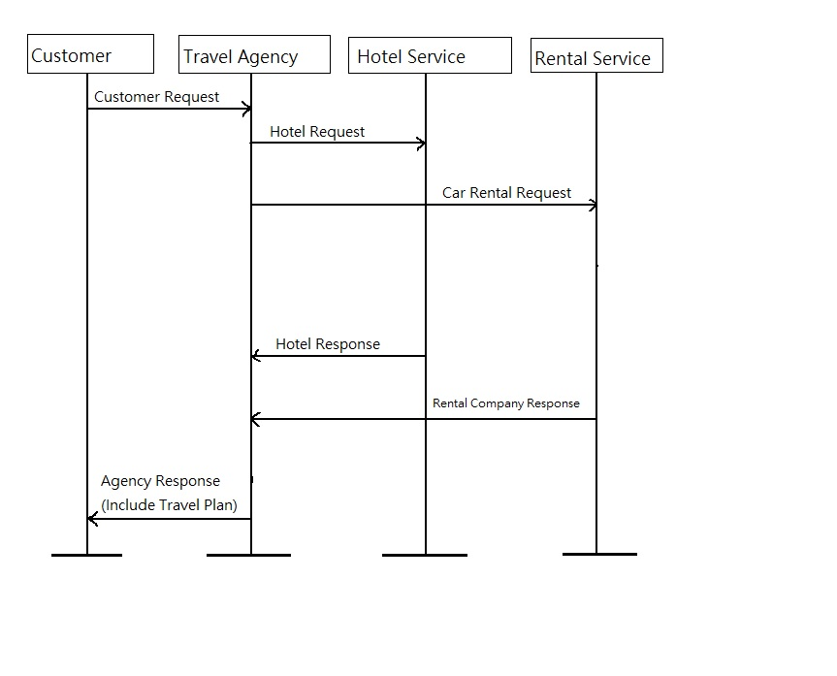

A customer can send service request to travel agency. Then travel agency can help them book for a car or a hotel. After that, just wait for the response.

One special part of this diagram is that the travel plan should be planned by the travel agency itself, there’s no need to send request to other company or services. So in this sequence diagram, the Travel Agency can provide the Travel plan itself